**Undergraduate Pharmacy Student enquiry form**

|  |  |
| --- | --- |
| Practice/PCN Name |  |
| Practice Manager/Contact - NHS Email |  |
| Practice Manager/Contact – Mobile Phone number |  |
| Hosting Practice/PCN (if different to the above-named practice) |  |
| Approximate capacity of students you can take on placement for 24/25 |  |
| ***Please select which or both universities you would like to support with placements:*** |  |
| University of Bradford (UOB) 2-day placements, Monday-Tuesday, and Wednesday-Thursday |  |
| University of Huddersfield (UOH) 5-day or 10-day placements Monday-Friday |  |
| Financial Manager Email (if not PM) |  |
| Locality |  |
| Can you commit to 16 weeks in the next academic year 24/25?  If no, please look at the planner attached below (***appendix 1***) and confirm what weeks you can accommodate. (Please note that there is crossover on some of the dates between UOH/UOB) |  |
| Date available for PARE audit/further discussion if required |  |

**Further information**

1. Employing Practice will be asked to invoice the university £3.49 p/hr for each student hosted, following confirmation of attendance at each locality placement, up to a maximum of £130 approx. per/week if full time (pro rata if 2-day placement), per/ student.
2. There is a requirement for the Host practice to ensure that they have an in-date environmental learning PARE audit in place prior to hosting the students. If this is near to or expired, an audit can be arranged either face to face or virtually and will take no more than 30-40- minutes to complete. The Practice Manager/Clinical Lead will be required to attend the audit, and this can be arranged through the Training Hub.
3. Once the above information has been received you will be linked in with the respective university.
4. Once the placement capacity/all information has been confirmed, participating students’ information will be communicated to the practice six weeks in advance of the placement.
5. All participating students will be invited to participate in an evaluation of the placement at the end of their time at the practice/PCN. This can be seen by the host on PARE, a profile will be provided for you.
6. Please find below (***appendix 2***) an example training plan for undergraduate pharmacy students, for your information only. PLEASE NOTE this is a guide only and has been kindly provided to us by ***Modality*** to support the ongoing recruitment of placement hosts.
7. The universities require six weeks’ notice prior to setting you up as a placement provider and one month should you wish to end your commitment with the universities. You can end your commitment at any time.
8. Please send this form back to the Training Hub with an email confirming your support to [**wy.traininghub@nhs.net**](mailto:wy.traininghub@nhs.net)

Appendix 1

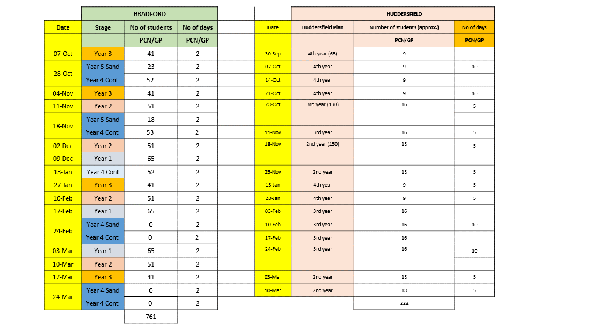

Appendix 2

|  |  |  |  |  |  |  |  |  |  |  |
| --- | --- | --- | --- | --- | --- | --- | --- | --- | --- | --- |
|  | **2 day rota** |  |  |  |  |  |  |  |  |  |
|  | Day 1 |  | Day 2 |  |  |  |  |  |  |  |
|  | 09:00 | Intro hour - tour of building, health and safety, introductions, and plan of placement | 09:00 | Sit with nurse or HCA for F2F clinic doing BP and bloods |  |  |  |  |  |  |
|  | 10:00 | Sit with Pharmacist to watch and discuss med review calls and appointments | 10:00 |  |  |  |  |  |  |
|  | 11:00 | 11:00 | Sit with Pharmacist doing duty queries |  |  |  |  |  |  |
|  | 12:00 | 12:00 |  |  |  |  |  |  |
|  | 13:00 | Lunch | 13:00 | Lunch |  |  |  |  |  |  |
|  | 14:00 | Sit with pharmacist tech | 14:00 | Sit with Pharmacist to watch and discuss med review calls and appointments |  |  |  |  |  |  |
|  | 15:00 | Sit with prescription team | 15:00 |  |  |  |  |  |  |
|  | 16:00 | Summary with pharmacist of first day - anything they want to cover? | 16:00 | Final summary with pharmacist and Q&A about anything |  |  |  |  |  |  |
|  |  |  |  |  |  |  |  |  |  |  |
|  |  |  |  |  |  |  |  |  |  |  |
|  | **5 day rota** |  |  |  |  |  |  |  |  |  |
|  | Day 1 |  | Day 2 |  | Day 3 |  | Day 4 |  | Day 5 |  |
|  | 09:00 | Intro hour - tour of building, health and safety, introductions, and plan of placement | 09:00 | Sit with nurse or HCA for F2F clinic doing BP and bloods | 09:00 | Sit with Pharmacist doing duty or Call list | 09:00 | Discuss how going so far anything missing then sit with Pharmacist to watch and discuss med review calls and appointments | 09:00 | Sit with Pharmacist to watch and discuss med review calls and appointments |
|  | 10:00 | Sit with Pharmacist to watch and discuss med review calls and appointments | 10:00 | 10:00 | 10:00 | 10:00 |
|  | 11:00 | 11:00 | Sit with Pharmacist doing duty queries | 11:00 | Sit with pharmacist tech | 11:00 | 11:00 | Sit with Pharmacist doing duty queries |
|  | 12:00 | 12:00 | 12:00 | Sit with prescription team | 12:00 | 12:00 |
|  | 13:00 | Lunch | 13:00 | Lunch | 13:00 | Lunch | 13:00 | Lunch | 13:00 | Lunch |
|  | 14:00 | Sit with pharmacist tech | 14:00 | Sit with Pharmacist to watch and discuss med review calls and appointments | 14:00 | Sit with other healthcare professional - GP or nurses | 14:00 | Sit with Pharmacist doing duty queries | 14:00 | Time for pharmacy student to decide what extra experience wanted |
|  | 15:00 | Sit with prescription team | 15:00 | 15:00 | 15:00 | 15:00 |
|  | 16:00 | Summary with pharmacist of first day | 16:00 | Summary with pharmacist and Q&A about anything | 16:00 | Summary with pharmacist and Q&A about anything | 16:00 | Summary with pharmacist and Q&A about anything | 16:00 | Final summary with pharmacist and Q&A about anything |